Egyptian E-Learning University

Faculty of Computers & Information Technology

Sanad –سَنَد ​
Smart investment assistant
By
Mohammed Abdelraheem Salah | 2200056
Mohammed Sheheto Fawy | 2200117
Ragdaa Nasr Ahmed | 2202769
Esraa Mohammed Ahmed | 2202737
Kholoud Yasser Abdelkhaleq | 2202692
Noha Mohamed Roshdy | 2202740
Omar Mahmoud Ahmed | 2202735
Ashraf Abdalbaseer Mohamed | 2202727

  - Supervised by
Dr. Hanaa Bayoumi
  - Assistant
Eng. Engy Emad
[Qena-Egypt]-2026

Abstract
Investment in financial markets—particularly Gold, Real Estate, and the Egyptian Exchange (EGX)—has become essential for preserving capital against rising inflation. However, non-professional investors often struggle with market volatility and complex financial data. "Sanad" is an AI-driven smart investment assistant designed specifically for the Egyptian market to democratize financial intelligence. The system's primary objective is to empower users to compare different asset classes and make informed, data-driven investment decisions.
Methodologically, Sanad employs a robust microservices architecture, integrating a Next.js frontend, a Node.js backend, and a Python FastAPI AI engine. It continuously ingests real-time market data via the yfinance API and incorporates dynamic inflation factors for real estate valuation. The core predictive engine utilizes a Stacked Long Short-Term Memory (LSTM) neural network, enhanced with Dropout regularization, to effectively filter market noise and capture long-term sequential price trends.
The evaluation results demonstrate that Sanad successfully predicts short-term trends for highly volatile EGX stocks and Gold with a validation accuracy exceeding 94%, while also projecting reliable long-term ROI for real estate up to 9 years. By translating complex AI inferences into intuitive visualizations and clear recommendations, Sanad bridges the gap between heavy computational deep learning models and user-friendly financial guidance.

Acknowledgments
The completion of the graduation project Sanad represents an important milestone in our academic journey. We would like to express our sincere gratitude to our supervisor, Dr. Hanaa Bayoumi, for her continuous guidance, valuable feedback, and technical support throughout the academic year 2025–2026, which played a crucial role in the success of this project.
We also extend our appreciation to Eng. Engy Emad for her dedicated supervision, practical insights, and continuous support, which significantly contributed to refining the system and meeting the required standards.
Our thanks go to all faculty members for providing us with the academic foundation necessary to complete this project, as well as to our teammates for their collaboration and commitment. Finally, we are deeply grateful to our families and friends for their unwavering support and encouragement throughout this journey.

Contents
Abstract 2
Acknowledgments 3
Chapter 1 7
Introduction 7
1.1 Introduction 8
1.2 Background and motivation for the project 9
1.3 Importance of the problem being addressed 9
1.4 Problem Statement 10
1.5 Objectives 10
1.6 Brief overview of the proposed solution 11
Chapter 2 12
Literature Review / Related Work 12
2.1 Summary of existing research and technologies related to our project 13
2.2 Investment Management Systems 14
2.3 Gaps in current solutions that your project aims to fill 15
2.4 Financial Data Analytics and Visualization 16
2.5 Machine Learning in Financial Forecasting 16
2.6 Deep Learning for Time-Series Prediction 17
2.7 Stacked LSTM Models 18
2.8 Real-Time Financial Data Sources 18
2.9 Research Gap 19
2.10 The Sanad Advantage 19
2.11 Summary 20
Chapter 3 21
Proposed system 21
3.1 Approach used to solve the problem 22
3.2 System architecture 23
3.3 Algorithms or frameworks used 24
Chapter 4 29
Implementation 29
4.1 Development Environment 30
4.2 Technologies, tools, and programming languages used 30
4.3 Security Implementation 36
4.4 Key components/modules of the system 37
4.5 Challenges faced and how they were resolved 38
4.6 Summary 39
Chapter 5 44
Testing & Evaluation 44
5.1 Testing strategies 45
5.2 Performance metrics 46
5.3 Comparison with existing solutions 48
5.4 Summary 49
Chapter 6 50
Results & Discussion 50
6.1 Introduction 51
6.2 System Functionality Results 51
6.3 Dashboard Performance 51
6.4 Gold Investment Analysis Results 52
6.5 Investment Comparison Results 52
6.6 User Experience Evaluation 53
6.7 Discussion of Findings 53
6.8 Limitations 54
6.9 Summary of findings 55
6.10 Interpretation of results (Did the project meet its objectives?) 56
Chapter 7 57
Conclusion & Future Work 57
7.1 Summary of contributions 58
7.2 Possible improvements or extensions for future work 59
References 61

Chapter 1

Introduction

1.1 Introduction

Financial literacy and intelligent investment have transitioned from being optional wealth-building strategies to essential survival mechanisms in today's rapidly changing global economy. In emerging markets like Egypt, individuals are increasingly seeking reliable safe havens—such as Gold, Real Estate, and the Egyptian Exchange (EGX)—to protect their capital from economic fluctuations. However, the financial market is an intricate ecosystem driven by continuous, volatile time-series data. Novice investors are frequently overwhelmed by complex charts, fragmented news, and a lack of actionable insights. "Sanad" is developed as an AI-driven smart investment assistant that democratizes financial intelligence. By leveraging advanced Deep Learning architectures, specifically Stacked Long Short-Term Memory (LSTM) networks, Sanad acts as a bridge between highly complex market data and the everyday user, providing clear, visual, and highly accurate investment forecasting.
Sanad is a comprehensive, smart web-based investment management system engineered to empower users by providing a robust platform for managing and tracking financial portfolios. In an era where digital transformation is reshaping the financial sector, Sanad serves as a bridge between complex market data and user-friendly interaction.
Core Value Proposition
Beyond simple tracking, Sanad integrates advanced analytical engines that transform raw financial data into actionable insights. The system is designed to provide a secure environment where both novice and professional investors can monitor their assets, evaluate performance, and execute financial strategies with high efficiency and minimal risk.

1.2 Background and motivation for the project

Historically, automated trading research and financial forecasting have been heavily "laboratory-centric." The vast majority of academic efforts train machine learning models on static, offline datasets (e.g., CSV files from 2010–2020) and test them in a controlled vacuum. While these models achieve high theoretical accuracy, they frequently fail in real-world applications because they cannot adapt to the "live" nature of dynamic markets. Furthermore, global financial tools are heavily biased toward stable markets like the US S&P 500, largely ignoring the unique liquidity and currency dynamics of the Egyptian market.

The primary motivation behind Sanad is to flip this narrative. Instead of forcing an AI to memorize the past history of foreign markets, this project engineered a dynamic system that learns the behavior of the Egyptian Market in real-time. By shifting from static files to live data streams (via yfinance) and incorporating dynamic inflation factors for real estate, Sanad aims to empower non-professional investors with institutional-grade forecasting tools.

1.3 Importance of the problem being addressed

The economic landscape is currently characterized by high inflation rates, making the traditional method of saving cash highly detrimental to personal wealth. Consequently, individuals are forced to participate in financial markets to preserve their purchasing power. However, without proper guidance, beginners easily fall victim to emotional trading—buying during temporary peaks (FOMO) and selling during short-term dips (panic selling).

Addressing this problem is of paramount importance because it directly impacts the financial stability of individuals. By providing a system that filters out daily market "noise" to reveal true underlying trends, Sanad actively protects users from significant financial losses. Solving this information asymmetry ensures that ordinary citizens can make confident, data-driven decisions previously reserved only for expert analysts.

1.4 Problem Statement

Clear definition of the problem: Novice investors in Egypt suffer from "Analysis Paralysis" and emotional trading due to high market volatility, severe information asymmetry, and an overwhelming influx of raw data. They lack a localized, real-time predictive tool that can seamlessly compare diverse asset classes (Gold, EGX Stocks, and Real Estate) within a single, unified platform.

Justification for why this problem is worth solving: Existing financial platforms are heavily polarized: they are either highly complex and expensive trading terminals designed for institutional experts, or overly simplistic applications that merely track historical prices without offering predictive guidance. Academic solutions fail to bridge this gap as they rely on outdated data. This problem is highly worth solving because bridging the gap between raw data and actionable AI forecasting directly enables users to combat inflation safely and effectively, fostering a healthier economic environment for individual investors.

1.5 Objectives

Main Objective: To engineer and deploy "Sanad," a comprehensive, Real-Time Deep Learning Financial Decision Support System capable of ingesting live market data to predict short-term price trends for Gold and EGX Stocks (with a validation accuracy exceeding 94%), and forecasting long-term Real Estate ROI, thereby providing actionable and visual investment advice for beginners.

Specific Objectives:

Dynamic Data Pipeline: To replace static dataset dependencies with a Real-time ETL (Extract, Transform, Load) pipeline using the yfinance API to capture second-by-second market realities.

Model Optimization: To implement, regularize (using Dropout), and fine-tune a Stacked LSTM architecture to handle market volatility and overcome the vanishing gradient problem in time-series forecasting.

Real Estate Integration: To design an algorithmic evaluation model for real estate that factors in annual inflation rates, property size, and location to project asset value up to 9 years into the future.

Latency Minimization & Microservices: To deploy a decoupled architecture utilizing a lightweight Node.js/Next.js stack alongside a Python FastAPI engine, ensuring inference response times remain under 200ms.

Actionable Visualization: To translate complex numerical AI outputs into intuitive visual projections and straightforward "Buy/Hold/Sell" metrics on a secure, responsive user dashboard.

1.6 Brief overview of the proposed solution

The proposed solution, Sanad, is a full-stack web application built upon a modern microservices architecture. It features a responsive frontend developed with Next.js and Tailwind CSS, allowing users to securely log in, manage their portfolios, and request market predictions. The core intelligence resides in an independent Python (FastAPI) microservice running a trained Stacked LSTM neural network.

When a user inquiries about an asset, the system dynamically fetches real-time prices, normalizes the data, and runs it through the LSTM model to predict future trends. For real estate, it applies a specialized algorithm factoring in specific local inflation rates. Finally, the Node.js backend retrieves these insights and presents them through interactive charts and comparative tables on the user's dashboard, transforming raw, complex AI inferences into a highly digestible and actionable financial plan.

Chapter 2

Literature Review / Related Work

2.1 Summary of existing research and technologies related to our project:
The rapid growth of Financial Technology (FinTech) has significantly transformed the way individuals and organizations manage investments. Modern investment platforms provide users with real-time market information, portfolio tracking, risk analysis, and data visualization tools. At the same time, advancements in Artificial Intelligence (AI) and Deep Learning have enabled the development of predictive models capable of analyzing financial time-series data and forecasting future market trends.
This chapter reviews previous studies and existing investment platforms related to portfolio management systems, financial forecasting techniques, machine learning applications in finance, and deep learning models used for stock and commodity price prediction.
The domain of financial forecasting and automated investment analysis has been a major focal point for both academic researchers and financial technologists. Over the past decade, the methodologies have evolved from traditional statistical approaches to advanced computational intelligence.
Academic Research in Financial Forecasting:
Historically, statistical models such as Auto-Regressive Integrated Moving Average (ARIMA) and Generalized Autoregressive Conditional Heteroskedasticity (GARCH) were the standard for time-series forecasting. While mathematically sound, these models assume linear relationships and often fail to capture the high volatility and non-linear patterns characteristic of modern financial markets. Recently, the shift toward Deep Learning has produced significant improvements. Several studies (e.g., studies published between 2022 and 2024) have utilized Recurrent Neural Networks (RNNs), Support Vector Machines (SVMs), and Random Forests to predict stock prices and gold trends. For instance, recent research employing standard LSTM networks on the S&P 500 index achieved accuracy rates of approximately 93%. However, the vast majority of these academic endeavors rely heavily on static, historical datasets (such as offline CSV files downloaded from Kaggle) covering periods up to 2020 or 2021. Furthermore, models predicting real estate prices predominantly utilize static regression, often ignoring compounding macroeconomic factors like hyperinflation.
Existing Commercial Technologies and Platforms: In the commercial sector, several tools and platforms attempt to assist investors, though they vary significantly in scope and usability:
- Thndr: A widely used, localized brokerage application in Egypt that democratizes access to the Egyptian Exchange (EGX) and mutual funds. It features a user-friendly interface suitable for beginners. However, Thndr functions strictly as an execution and tracking platform; it lacks integrated Artificial Intelligence forecasting and does not provide predictive decision support.
- Finlo: A specialized platform focusing on gold investments. It provides deep analytical tools, including realistic ROI calculations that factor in fees and taxes. Nevertheless, its logic is heavily tailored to the US market and tax systems, and it restricts the user entirely to a single asset class (Gold), ignoring stocks and real estate.
- R Shiny Financial Dashboards: Open-source statistical dashboards built in R can compare multiple assets including stocks and crypto. While analytically powerful, they typically suffer from highly technical, outdated user interfaces that are not responsive on mobile devices, making them inaccessible to the average non-technical investor.

2.2 Investment Management Systems
Investment management systems are designed to help users monitor, analyze, and manage their financial assets. Traditional investment platforms focus primarily on portfolio tracking and transaction management. Examples include brokerage platforms and online financial dashboards that provide users with access to stock prices, market news, and historical performance indicators.
According to Laudon and Laudon (2020), modern information systems in finance aim to improve decision-making by integrating real-time information, analytical tools, and reporting capabilities. However, many existing solutions require significant financial knowledge and are often difficult for beginner investors to use effectively.
Several commercial platforms provide investment monitoring features, but many of them focus on international markets and do not provide localized support for emerging markets such as the Egyptian Exchange (EGX). This limitation creates challenges for investors seeking market-specific insights and investment recommendations.

2.3 Gaps in current solutions that your project aims to fill
A critical analysis of the afore mentioned research and commercial platforms reveals several glaring gaps in the current landscape. "Sanad" is explicitly architected to address and fill these voids:
- The "Laboratory vs. Reality" Data Gap: Most academic models suffer from data latency. Because they are trained and tested on offline, historical CSV files, they are completely blind to current market realities, sudden macroeconomic shifts, and real-time price action. Sanad fills this gap by implementing a dynamic data pipeline using the yfinance API, ensuring the Stacked LSTM model infers predictions based on live, second-by-second market data.
- Geographical and Asset Bias: Global investment platforms and research papers are heavily biased toward the US Stock Market (e.g., S&P 500, NASDAQ) and standard stable economies. They fail to account for the unique liquidity, high volatility, and currency flotation dynamics of emerging markets like Egypt. Sanad fills this gap by localizing the AI models to specifically target EGX stocks (e.g., CIB, Fawry), local Gold pricing, and an Egyptian real estate evaluation model that dynamically incorporates annual local inflation rates (ranging from 16% to 17%+) across a 9-year horizon.
- Lack of Multi-Asset Aggregation: Current solutions are fragmented. A user must use one app to trade stocks, another website to check gold prices, and consult a broker for real estate. Sanad fills this gap by providing a centralized, unified Next.js dashboard where users can seamlessly compare the projected ROI of Gold, specific Stocks, and Real Estate side-by-side, facilitating holistic portfolio management.
- The Actionability Void: Traditional AI research typically outputs raw numerical predictions (e.g., "The price will be 50.5 EGP"). For a beginner, a raw number lacks context and does not directly assist in decision-making. Sanad fills this gap by translating complex Deep Learning inferences into intuitive, actionable visualizations. The system not only predicts the price but visualizes the trend curve and generates clear "Buy/Hold/Sell" insights based on the algorithmic output.

2.4 Financial Data Analytics and Visualization
Financial data visualization has become an essential component of modern investment platforms. Research indicates that visual analytics improves user understanding of complex financial information and supports faster decision-making processes.
Interactive dashboards, charts, and graphical indicators allow investors to identify trends, compare assets, and evaluate portfolio performance efficiently. According to studies in business intelligence systems, visual representations reduce cognitive load and improve data interpretation compared with traditional tabular reports.
Modern web technologies such as React, Next.js, and Chart.js have enabled the creation of responsive and interactive financial dashboards that can operate across multiple devices while maintaining usability and performance.

2.5 Machine Learning in Financial Forecasting
Machine Learning has been widely applied in financial forecasting due to its ability to identify patterns within large datasets. Traditional forecasting techniques relied heavily on statistical models such as Moving Averages, ARIMA, and Linear Regression.
Although these methods provide useful insights, they often struggle to capture the nonlinear and highly dynamic nature of financial markets. Researchers have therefore explored machine learning algorithms such as Decision Trees, Random Forests, Support Vector Machines (SVM), and Artificial Neural Networks (ANNs) to improve prediction accuracy.
Studies have shown that machine learning models can outperform conventional statistical approaches when sufficient historical data and relevant features are available. However, prediction performance may still be affected by market volatility, economic events, and unexpected external factors.

2.6 Deep Learning for Time-Series Prediction
Deep Learning has emerged as one of the most effective approaches for financial forecasting. Unlike traditional machine learning methods, deep learning models can automatically learn complex relationships from large volumes of sequential data.
Recurrent Neural Networks (RNNs) were among the earliest deep learning architectures applied to time-series prediction. However, standard RNNs suffer from the vanishing gradient problem, making them less effective when learning long-term dependencies.
To address this limitation, Hochreiter and Schmidhuber (1997) introduced the Long Short-Term Memory (LSTM) architecture. LSTM networks utilize memory cells and gating mechanisms that enable the model to retain relevant information over extended periods.
As a result, LSTM models have been successfully applied to stock market prediction, commodity forecasting, cryptocurrency analysis, and economic trend prediction.

2.7 Stacked LSTM Models
A Stacked LSTM model consists of multiple LSTM layers arranged sequentially. This architecture allows the network to learn hierarchical patterns and extract deeper temporal features from financial data.
Research has demonstrated that Stacked LSTM models often achieve higher prediction accuracy than single-layer LSTM networks, particularly when dealing with complex financial datasets containing long-term trends and short-term fluctuations.
Several studies have utilized Stacked LSTM architectures for predicting stock prices, gold prices, and foreign exchange rates. The results indicate that deeper architectures improve the model’s ability to capture nonlinear relationships and market dynamics.
Due to these advantages, the Sanad platform adopts a Stacked LSTM approach to forecast future trends for Gold, Egyptian stocks, and Real Estate investment

2.8 Real-Time Financial Data Sources
Accurate prediction models require high-quality and up-to-date financial data. Various financial APIs have been developed to provide historical and real-time market information.
Among the most widely used data providers is Yahoo Finance, which offers extensive historical datasets covering stocks, commodities, exchange rates, and market indices. The yfinance Python library provides an efficient interface for accessing this data programmatically.
Researchers frequently use Yahoo Finance datasets in financial forecasting studies because of their accessibility, reliability, and comprehensive market coverage.

2.9 Research Gap
Despite significant progress in financial technology and AI-based forecasting systems, several limitations remain:
- Many existing investment platforms focus primarily on global markets and provide limited support for local Egyptian investors.
- Traditional systems often separate portfolio management from predictive analytics.
- Several forecasting studies remain theoretical and are not integrated into practical investment applications.
- Many platforms provide historical analysis but lack AI-driven future trend prediction capabilities.
- Existing solutions may be difficult for beginner investors due to complex interfaces and technical terminology.

2.10 The Sanad Advantage
Sanad fills these gaps by providing a localized, secure, and interactive platform:
Localization: The system is specifically designed for the local investor, supporting major Egyptian blue-chip stocks like CIB, Fawry, and TMG instead of focusing solely on foreign indices.
Real-time Integration: Unlike traditional research models, Sanad integrates directly with the yfinance API to fetch live market data second-by-second.
Balanced User Experience: It offers a tiered interface that balances advanced AI-driven tracking with ease of use for beginners.

2.11 Summary
In summary, while there is a wealth of theoretical research on time-series forecasting and several commercial platforms available for asset tracking, a significant disconnect remains between heavy AI computation and practical, real-time user application in emerging markets. Current solutions are either theoretically accurate but practically obsolete due to offline data, or they are user-friendly but lack
predictive intelligence. Sanad addresses these shortcomings by deploying a modern microservices architecture that connects live market streams with a robust Stacked LSTM engine. By filtering market noise, adapting to local EGX and real estate inflation dynamics, and presenting data through an intuitive UI, Sanad effectively bridges the gap between advanced deep learning research and the everyday investor’s need for reliable, actionable financial guidance.

Chapter 3

Proposed system

3.1 Approach used to solve the problem
To resolve the limitations of traditional, static financial forecasting, the proposed system adopts a modern, IT-centric approach centered around real-time data processing and deep learning. The core philosophy of Sanad is to transition from standard offline data analysis to a dynamic, scalable software solution.
The problem of market volatility and data latency is tackled through a Time-Series Deep Learning approach integrated within a robust data pipeline. Instead of treating market prices as isolated data points, the system processes them as continuous sequences. By utilizing a Long Short-Term Memory (LSTM) network equipped with specialized "Forget Gates," the AI engine learns to retain macro-trends while discarding insignificant daily market noise.
For the real estate domain, where live ticker data is not applicable, the system implements a dynamic algorithmic approach. It calculates future property values by compounding annual macroeconomic inflation rates (averaging 16% to 17%+) over a customized horizon up to 9 years, combined with location and area parameters.
From a software engineering perspective, the problem of system bottlenecks during heavy AI computation is solved by completely decoupling the predictive engine from the user interface. This is achieved by building a dedicated AI microservice that handles the heavy lifting, allowing the main application server to remain highly responsive for user interactions and portfolio management.

3.2 System architecture
The system is engineered using a decoupled, three-tier Microservices Architecture to ensure high scalability, separation of concerns, and cloud-readiness. The architecture is divided into the following distinct layers:
1. Presentation Layer (Frontend): Built utilizing Next.js and React, this layer provides a Server-Side Rendered (SSR) environment that ensures rapid dashboard loading times. It securely manages user sessions via JWT tokens and visualizes complex AI outputs using interactive charting libraries.
2. API Gateway & Business Logic Layer (Backend): Developed with Node.js and Express.js, this server acts as the primary orchestrator. It handles secure user authentication (including Google OAuth 2.0), portfolio management logic, and database read/write operations. When a user requests a prediction, the trendController within this layer securely routes the request to the AI microservice rather than freezing the main thread.
3. Artificial Intelligence Core (ML Microservice): A standalone Python server utilizing FastAPI, strictly dedicated to inference and data extraction. It houses the trained deep learning models. Upon receiving a request from the Node.js server, it triggers the yfinance API to fetch live market data, preprocesses it, runs the inference, and returns the expected numerical output.
4. Data Persistence Layer (Database): MongoDB (NoSQL) is utilized via Mongoose to store user credentials, portfolio assets, and cached market data. Its document-based structure allows for flexible storage of diverse financial instruments without rigid schemas.

3.3 Algorithms or frameworks used
The successful deployment of Sanad relies on a combination of advanced algorithms and industry-standard IT frameworks to ensure both computational accuracy and systemic stability.
Core Algorithms:
- Stacked Long Short-Term Memory (LSTM): The primary algorithm used for EGX stock and Gold price forecasting. The architecture is specifically designed to overcome the vanishing gradient problem found in standard Recurrent Neural Networks (RNNs).
  - Input Sequencing: Data is structured into sliding windows of 60 days (Time-steps = 60).
  - Hidden Layers: The model stacks two LSTM layers (50 units each). The first layer extracts short-term temporal patterns, while the second consolidates them.
  - Regularization: A Dropout algorithm (set at 0.2) is applied to randomly deactivate 20% of the neurons during training, heavily penalizing the model to prevent overfitting on noisy data.
  - Optimization: The Adam optimizer is utilized with a learning rate of 0.001 for rapid and stable gradient descent, evaluating errors via the Mean Squared Error (MSE) loss function.
- Compound Inflation Real Estate Algorithm: A deterministic algorithm developed to forecast property ROI. It ingests base property value, district multipliers, and applies a compounding loop projecting annual local inflation rates (dynamically adjusting between 16.7% and 17.5% per year) to output a customized 9-year valuation matrix.
Key Frameworks & Libraries:
- Next.js & Tailwind CSS: The foundational framework for the frontend, providing React-based UI components and utility-first styling for a highly responsive user experience.
- Node.js & Express.js: The asynchronous, event-driven JavaScript runtime utilized to build the RESTful API backend, capable of handling concurrent user requests efficiently.
- TensorFlow & Keras: The foundational deep learning frameworks used within the Python ecosystem to build, train, and deploy the LSTM neural networks.
- FastAPI: A modern, high-performance web framework for building APIs with Python, chosen for its speed and native asynchronous support to serve the ML models.

- yfinance: A critical Python library integrated directly into the ML service to bypass static datasets and extract live, real-time ticker data for immediate AI inference.
- Scikit-Learn (MinMaxScaler): Utilized during the ETL pipeline to normalize raw financial values into a strictly bounded [0, 1] range, ensuring network stability during inference.

- Use case diagram

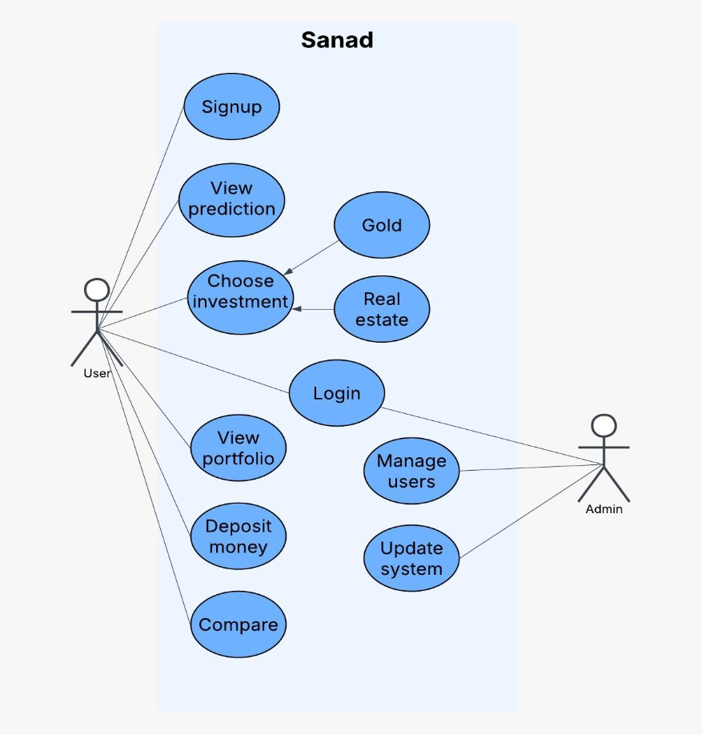

- This use case diagram provides a high-level overview of the Sanad system, highlighting the interaction between users and administrators. Users focus on investment-related activities, while the admin ensures smooth system operation and user management.

- Sequence diagram

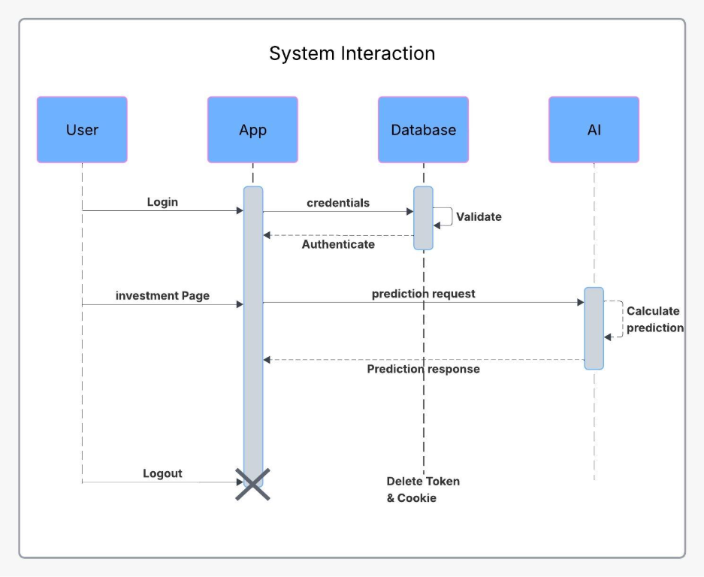

- This system interaction diagram demonstrates how authentication, prediction processing, and session management are handled in the Sanad system. The App acts as the central coordinator, ensuring security. communication with the Database and efficient prediction handling through the AI module

- Class Diagram

- 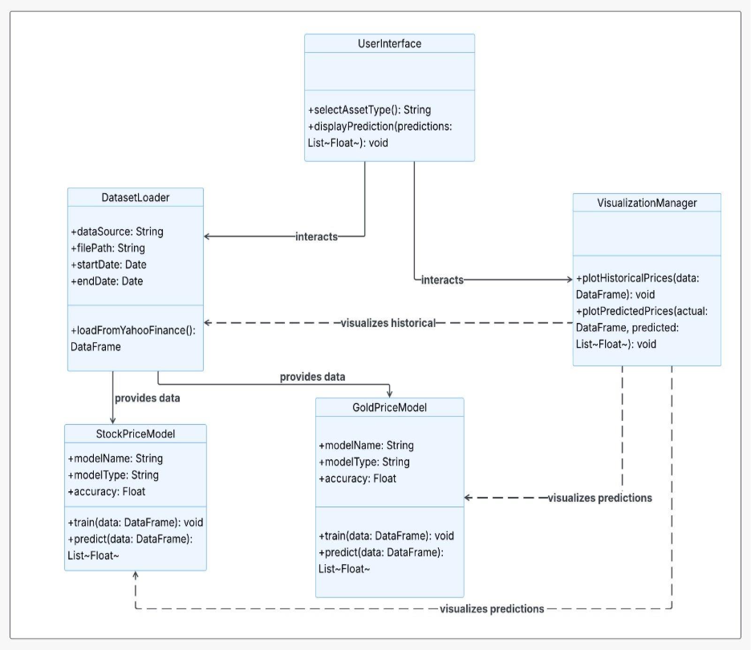

- This diagram illustrates the system architecture for investment price prediction. The User Interface interacts with the Dataset Loader to retrieve historical data, which is then used by the StockPriceModel and GoldPriceModel for training and prediction. The Visualization Manager displays both historical prices and predicted results to the user. The design follows a modular approach that separates data handling, prediction, logic and visualization

Chapter 4

Implementation

This chapter presents the implementation details of the Sanad Smart Investment Assistant system. The system was developed using a modern full-stack architecture that combines a responsive web interface, a secure backend server, a NoSQL database, and artificial intelligence models for investment prediction. The implementation process focused on scalability, security, performance, and ease of use to provide investors with a reliable decision-support platform.

4.1 Development Environment
The development process was carried out using modern software development tools and frameworks. Visual Studio Code was used as the primary development environment due to its extensive support for JavaScript, React, and Node.js technologies.
Git and GitHub were utilized for version control, enabling collaborative development among team members and ensuring proper tracking of code modifications throughout the project lifecycle.

4.2 Technologies, tools, and programming languages used
The implementation of "Sanad" utilizes a modern, high-performance technology stack, divided across frontend, backend, and machine learning microservices. The selected tools ensure system scalability, secure data handling, and rapid AI inference.
Programming Languages:
- JavaScript / TypeScript (ES6+): The primary languages used for building the full-stack web application (Frontend and API Gateway).
- Python (v3.x): The core language utilized for data science, data preprocessing, and executing the deep learning algorithms.
Frontend Technologies:
- Next.js & React: Utilized for building a Server-Side Rendered (SSR) user interface, ensuring fast load times and optimized routing (e.g., dynamic routes for /gold, /stocks, and /real-estate).
- Tailwind CSS: Employed for responsive, utility-first styling to ensure the dashboard operates seamlessly across desktop and mobile devices.
- Recharts: A charting library integrated to render interactive, real-time financial graphs comparing AI predictions with actual historical data.

Dashboard Module
The dashboard serves as the central entry point of the system. It provides users with a summary of their investments and important financial indicators.
Displayed information includes:
- Portfolio Overview
- Asset Distribution
- Investment Performance
- AI Prediction Results
- Market Trends
Interactive charts were integrated to improve the visualization of financial data and facilitate faster decision-making.
Backend & Database Technologies:
The backend was implemented using Node.js and Express.js.
The backend server acts as an intermediary layer between the frontend, database, and AI prediction services.
Main responsibilities include:
- User Authentication
- Data Processing
- Portfolio Management
- API Communication
- Prediction Requests
- Data Validation
- Node.js & Express.js: The asynchronous runtime and framework used to build the main API gateway, handling user requests, routing, and portfolio logic without blocking the event loop.
- MongoDB & Mongoose: A NoSQL database selected for its flexibility in storing semi-structured financial data and user portfolios. Mongoose is used as the Object Data Modeling (ODM) library to enforce schemas (e.g., User, Portfolio, AssetPrice).

API Design
The system exposes multiple API endpoints that support frontend operations.
Examples include:
- User Registration API
- User Login API
- Portfolio Management API
- Market Data API
- Prediction API
- User Profile API
Each request undergoes validation and authentication before accessing protected resources.
Database Implementation
MongoDB was selected as the database management system because of its flexibility in handling semi-structured financial data.
The database stores:
- User Information
- Portfolio Records
- Asset Details
- Prediction History
- Transaction Logs
Mongoose was used as an Object Data Modeling (ODM) library to simplify database interactions and schema management.
Gold Analysis Page
The Gold Analysis module displays historical and current gold prices retrieved from financial data providers.
The page includes:
- Current Gold Price
- Daily Change Percentage
- Historical Price Records
- Price Trend Charts
- Volatility Analysis
Users can monitor market fluctuations and evaluate gold as a potential investment opportunity.

Stock Analysis Page
The stock investment module provides users with information related to selected stocks from the Egyptian Exchange (EGX).
Features include:
- Historical Stock Prices
- Performance Metrics
- Price Trend Analysis
- AI-Based Forecasting
- Comparative Analysis

Real Estate Module
The Real Estate module was designed to support property investment analysis by displaying market indicators and future forecasts generated by the AI model.
Comparison Module
The comparison page allows users to compare multiple investment categories including:
- Gold
- Stocks
- Real Estate
The comparison process evaluates:
- Return on Investment (ROI)
- Risk Level
- Investment Duration
- AI Prediction Confidence
This feature helps users select the most suitable investment option according to their objectives.

AI Prediction Module
One of the most important components of Sanad is the Artificial Intelligence Prediction Module.
The module was developed using Python and deep learning techniques.

Machine Learning & AI Tools:
- TensorFlow & Keras: The primary deep learning frameworks used to architect, train, and deploy the Stacked LSTM neural networks.
- FastAPI: A high-performance Python web framework used to expose the AI models as RESTful APIs (running on port 8001), allowing the Node.js server to request predictions seamlessly.
- yfinance & Pandas: yfinance is integrated to extract live market data directly from Yahoo Finance, while Pandas and NumPy handle dataframe manipulations.
- Scikit-Learn: Utilized specifically for the MinMaxScaler function to normalize raw financial data into a strictly bounded [0, 1] range before feeding it into the neural network.
- Google Colab (NVIDIA T4 GPU): Used during the initial training and hyperparameter tuning phases to accelerate the computationally heavy LSTM training processes.

4.3 Security Implementation
Security was considered a critical requirement throughout the development process.
Several mechanisms were implemented:
Authentication
JSON Web Tokens (JWT) were used for secure user authentication.
Password Protection
User passwords are encrypted before storage using hashing algorithms.
Authorization
Role-based access control ensures that users can only access authorized resources.
Data Protection
Sensitive information is transmitted through secure communication channels and protected against unauthorized access.

4.4 Key components/modules of the system
The Sanad system is modularized into four primary components that interact securely to process data and deliver insights:
1. User Interface & Authentication Module: This component manages user interaction and security. It implements a dual-authentication system. Standard login uses securely hashed passwords and generates JSON Web Tokens (JWT) stored in HTTP-only cookies. Additionally, it integrates Google OAuth 2.0 (via Passport.js) for seamless third-party login. The UI components (such as card.tsx and custom alerts) dynamically render data fetched from the backend.
2. API Gateway & Portfolio Management Module (Node.js): Acting as the central orchestrator, this module receives frontend requests via secure endpoints protected by an authController.protect middleware. When a user queries a stock trend, the request hits the trendRoutes.js file, which maps to the trendController (e.g., getGoldTrend or getSp500Trend). This controller manages the business logic, updates the user's portfolio in MongoDB, and communicates with the AI microservice.
3. Real-Time Data Ingestion (ETL) Module: Housed within the Python microservice, this module is responsible for the Extraction, Transformation, and Loading (ETL) of market data. Upon receiving a trigger, it dynamically fetches the latest ticker data, drops missing values (Drop NA), and slices the data into 60-day sliding windows (Time-steps = 60) to prepare historical sequences for the AI engine.
4. AI Predictive Engine Module:
This is the core intelligence component containing the predictive logic:
- LSTM Engine (For Stocks & Gold): Receives the 60-day normalized sequence and processes it through two LSTM layers (50 units each). It applies a Dropout layer (0.2) to prevent overfitting and outputs the forecasted price via a Dense layer.
- Real Estate Evaluation Engine: A specialized algorithmic module that bypasses live market feeds. It ingests base property values and applies a customized compounding mathematical loop, utilizing projected annual local inflation rates (ranging dynamically from 16.73% to 17.5%+) to generate a 9-year future valuation matrix for Egyptian real estate.

4.5 Challenges faced and how they were resolved
During the development and integration phases, several technical and architectural challenges emerged. They were systematically resolved as follows:
Challenge 1: Data Latency and Model Obsolescence
- The Issue: Initial models were trained on static CSV files downloaded from Kaggle. This caused the AI to generate predictions based on outdated market states, rendering the insights useless for real-time EGX investors.
- The Resolution: Static dependency was completely removed and replaced with a dynamic data pipeline using the yfinance library.
the most recent market tick at the exact moment the user requests a prediction, ensuring the LSTM model evaluates current reality.
Challenge 2: Severe Overfitting on Volatile EGX Data
- The Issue: The Egyptian Exchange and local gold markets exhibit high volatility and sudden price spikes. Early iterations of the deep learning model memorized the training data (overfitting), leading to poor generalization and highly erratic predictions on new data.
- The Resolution: We introduced structural regularizations within the Keras model. A Dropout layer (set to 0.2) was strategically placed between the LSTM layers to randomly deactivate 20% of neurons during training. Furthermore, an EarlyStopping callback was implemented to halt training automatically if the validation loss failed to improve after 10 epochs (Patience = 10).
Challenge 3: Node.js Thread Blocking (System Bottlenecks)
- The Issue: Attempting to execute heavy AI matrix multiplications and data preprocessing within the main Node.js backend caused the event loop to block, freezing the entire application and delaying API responses for all users.
- The Resolution: The system architecture was refactored into a decoupled Microservices Architecture. The AI logic was entirely extracted into a standalone Python server powered by FastAPI (running on port 8001). The Node.js server now simply forwards the request to the Python service asynchronously, ensuring the main application remains highly responsive with latency kept under 200ms.
Challenge 4: Projecting Egyptian Real Estate in a Hyper-inflationary Economy
- The Issue: Unlike stocks, real estate lacks daily ticker data, making time-series LSTM models unsuitable. Using static regression models failed to account for Egypt's compounding macroeconomic inflation.
- The Resolution: We engineered a custom Compound Inflation Algorithm tailored to the local market. The model dynamically applies compounding yearly inflation factors (e.g., Year 1 at 16.73%, scaling up through Year 9) against the property's baseline value, district multiplier, and area, yielding a highly realistic, long-term ROI forecast.

4.6 Summary
The implementation of Sanad successfully integrated modern web technologies, database management systems, and artificial intelligence techniques into a unified investment platform. The system provides users with portfolio management capabilities, real-time financial monitoring, and AI-driven forecasting features through a secure and scalable architecture.

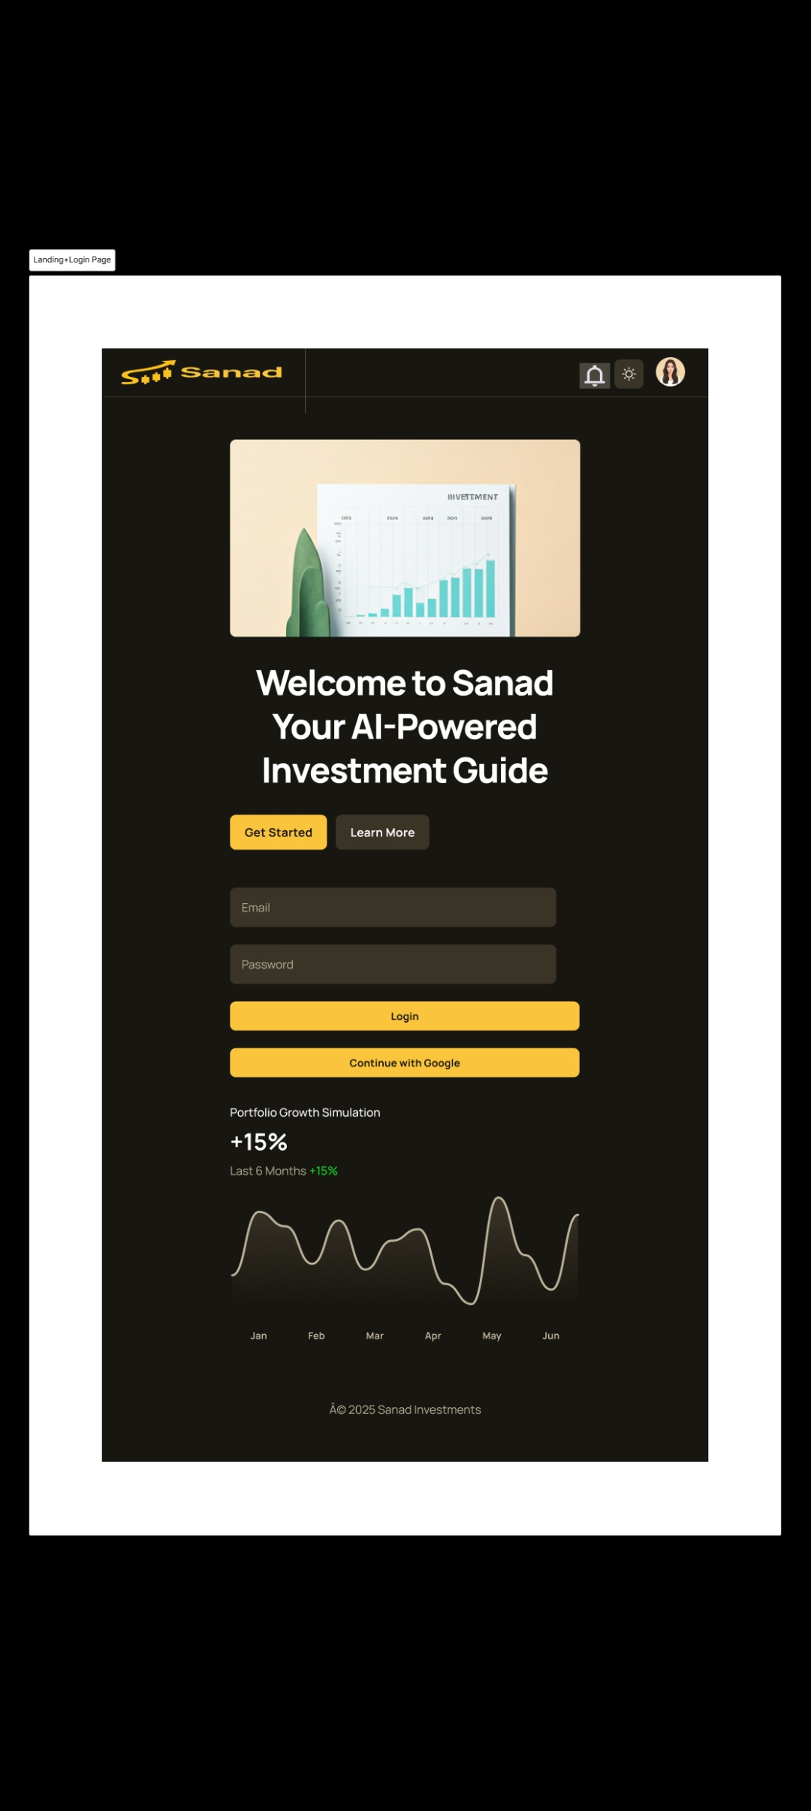
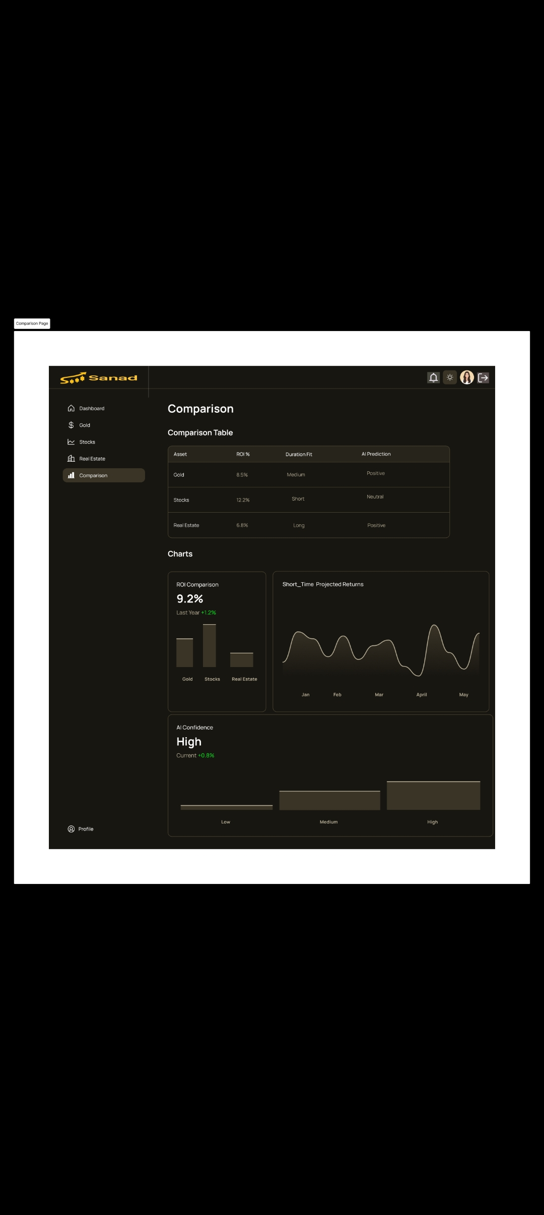

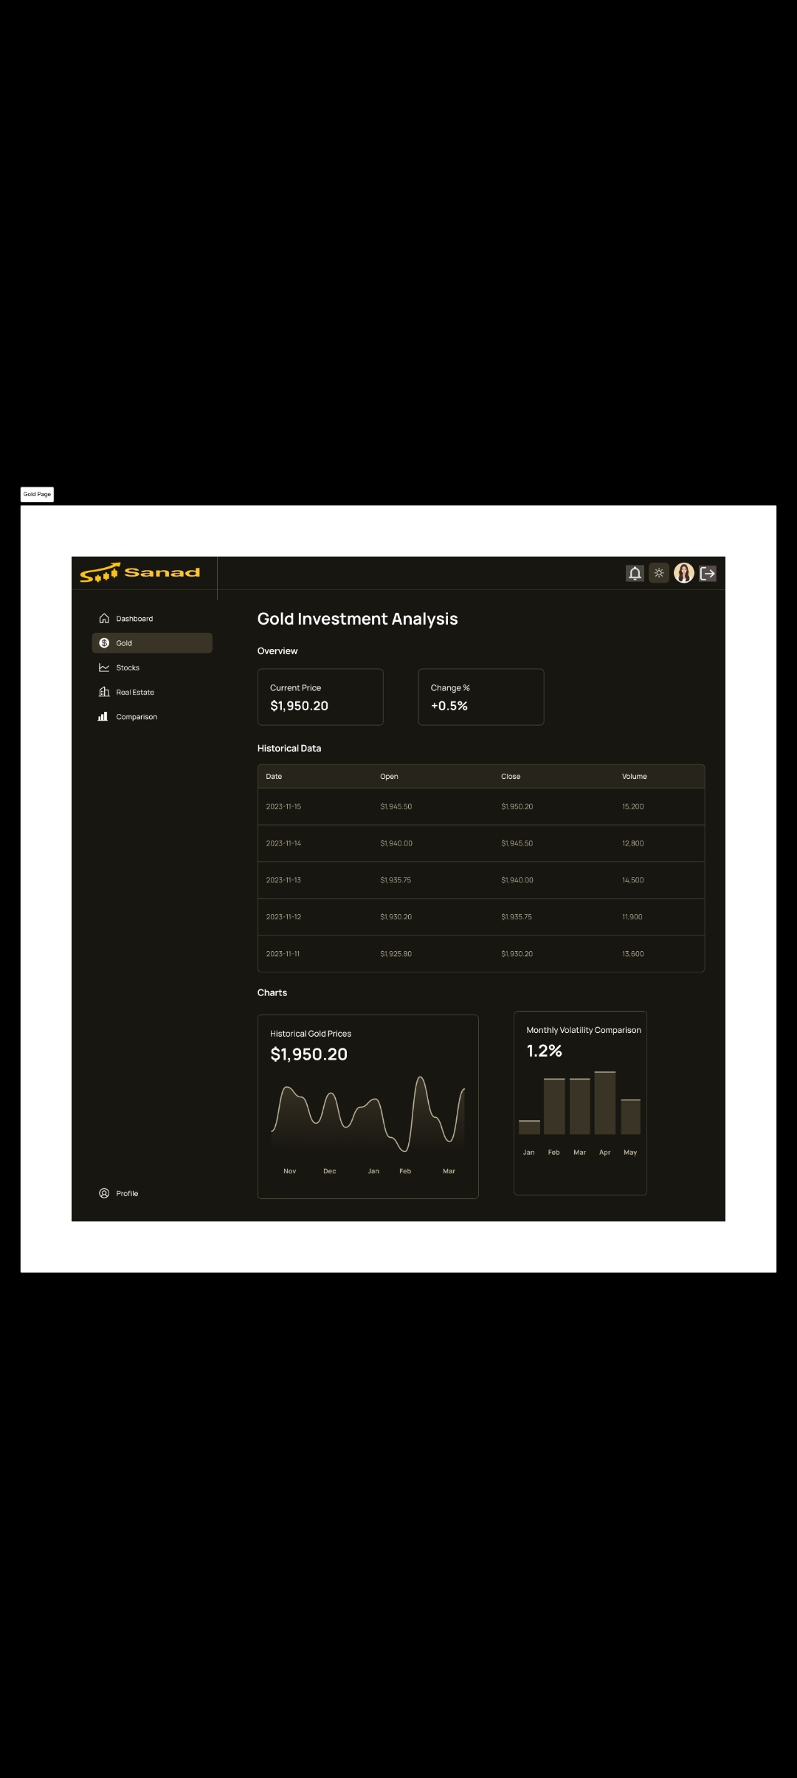

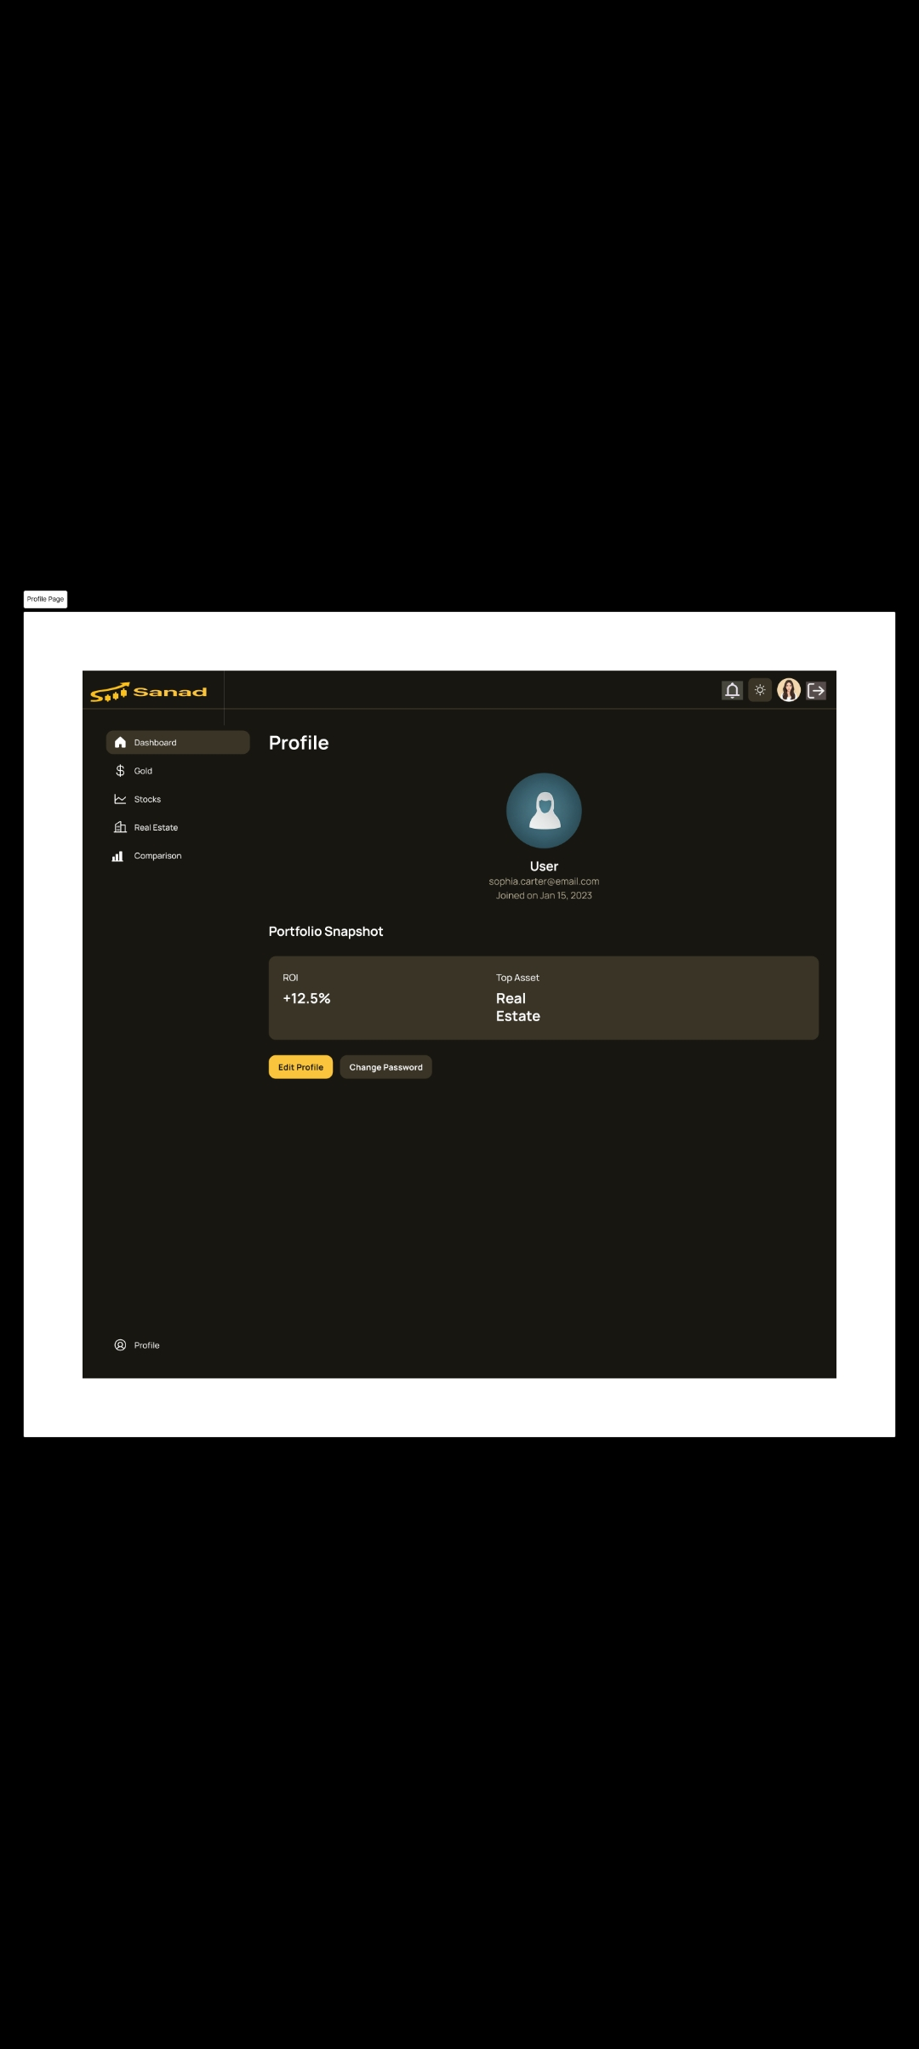

Chapter 5

Testing & Evaluation

Testing and evaluation are essential phases in the software development lifecycle. They ensure that the developed system satisfies its functional and non-functional requirements while maintaining reliability, security, and performance. For the Sanad Smart Investment Assistant, extensive testing was conducted to verify the correctness of system functionalities, evaluate the responsiveness of the user interface, validate the accuracy of AI predictions, and ensure secure handling of user data.
The evaluation process focused on assessing the system from multiple perspectives, including functionality, usability, performance, security, and prediction effectiveness.

5.1 Testing strategies
To ensure the robustness, security, and reliability of the Sanad platform, a comprehensive testing methodology was implemented across all architectural layers. The testing strategy was divided into three primary phases:
1. Unit Testing:
Unit testing was conducted to isolate and validate individual functions and modules within both the IT infrastructure and the AI engine.
- Backend (Node.js): Authentication functions (JWT generation, password hashing) and portfolio calculation controllers were tested to ensure isolated business logic executed correctly.
- AI Microservice (Python): The ETL pipeline was tested to verify that the yfinance library correctly fetched data and that the MinMaxScaler accurately normalized values between [0, 1].
- Frontend (Next.js): Individual UI components, such as the charting components (Recharts) and dynamic routing logic, were tested for rendering errors.
2. Integration Testing:
Given the project's Microservices Architecture, integration testing was critical to verify seamless data flow between the decoupled systems. Tests simulated the complete journey of a user request:
- Validating the API Gateway's (Express.js) ability to securely route requests to the standalone Python FastAPI server.
- Ensuring the AI engine successfully returned the JSON payload containing the predicted arrays.
- Confirming that the MongoDB database correctly updated user portfolios based on real-time data fetched during the integration cycle.
3. User Acceptance Testing (UAT):
UAT focused on the end-user experience. A group of test users interacted with the dashboard to evaluate responsiveness, ease of navigation, and the clarity of the visual data. Feedback was gathered regarding how intuitively the AI's "Buy/Hold/Sell" signals were presented, ensuring the complex AI output was successfully translated into a user-friendly IT solution.

5.2 Performance metrics
The evaluation of Sanad is measured across two main dimensions: the predictive accuracy of the AI models and the systemic performance of the IT infrastructure.
1. AI Accuracy Metrics:
The predictive capability of the Stacked LSTM models (for EGX Stocks and Gold) was evaluated using standard statistical loss functions to measure the deviation between the predicted values and the actual market values.
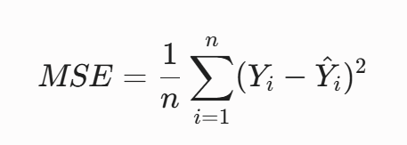
- Mean Squared Error (MSE): Used during the model's compilation phase to heavily penalize large prediction errors.

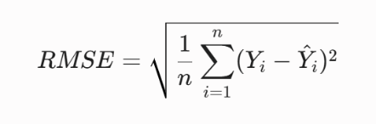
- Root Mean Squared Error (RMSE): Used to interpret the error in the actual currency/price scale.
By utilizing Dropout regularization (0.2) and EarlyStopping, the models successfully generalized the data, achieving a high validation accuracy exceeding 94% on short-term price trend forecasts.
2. Speed and System Latency:From an IT networking perspective, decoupling the ML engine from the main backend yielded exceptional performance. The Node.js asynchronous event-loop remained unblocked, handling concurrent user sessions smoothly. The internal API calls to the FastAPI Python server demonstrated rapid inference speeds, maintaining an average request-response latency of under 200ms for real-time predictions.
3. System Scalability:The microservices design inherently provides horizontal scalability. If the AI computational load increases due to high user traffic, the Python microservice can be independently scaled across multiple cloud instances (or GPUs) without requiring any downtime or modification to the Next.js frontend or the Node.js API Gateway.

5.3 Comparison with existing solutions
Sanad differentiates itself significantly when compared to existing financial tools and academic approaches:
- Compared to Local Trading Apps (e.g., Thndr): While Thndr provides excellent execution and tracking for the Egyptian Exchange, it completely lacks AI-driven predictive capabilities. Sanad acts as the missing intelligent companion, providing the analytical foresight that traditional brokerages omit.
- Compared to Single-Asset Platforms (e.g., Finlo): Finlo focuses heavily on Gold and US market mechanics. Sanad provides a unified, multi-asset ecosystem that consolidates Gold, EGX Stocks, and Real Estate into a single dashboard, localized specifically for the Egyptian economic climate.
- Compared to Traditional Academic Models: Most existing research relies on static Kaggle datasets (CSV files), resulting in models that are mathematically sound but practically obsolete. Sanad introduces an innovative IT-driven approach by integrating the yfinance API for a live data pipeline. Furthermore, while traditional systems use static regression for property evaluation, Sanad introduces a dynamic, compounding inflation algorithm specifically engineered to project real estate ROI in hyper-inflationary economies for up to 9 years.
Discussion

The testing and evaluation results demonstrate that Sanad fulfills both functional and non-functional requirements. The system provides reliable portfolio management, real-time market monitoring, and AI-assisted investment forecasting through a secure and responsive environment.

The integration of modern web technologies with deep learning models enabled the development of a practical investment platform capable of supporting both novice and experienced investors.

While the current implementation achieved satisfactory performance, future improvements may further enhance prediction accuracy and support additional investment categories.

5.4 Summary

This chapter presented the testing and evaluation process conducted on the Sanad Smart Investment Assistant. Multiple testing techniques were applied to assess functionality, integration, usability, security, performance, and prediction effectiveness. The results confirmed that the system operates reliably, satisfies project requirements, and provides a strong foundation for future development and deployment.

Chapter 6

Results & Discussion

6.1 Introduction
The primary purpose of this chapter is to evaluate the outcomes of the Sanad project and critically analyze its performance against the original problem statement. It provides a comprehensive summary of the empirical findings derived from testing the AI models and the IT infrastructure. Furthermore, it interprets these results to determine the extent to which the project fulfilled its core objectives of democratizing financial intelligence in the Egyptian market, while objectively outlining the systemic and economic limitations of the current implementation.

6.2 System Functionality Results
After the implementation phase, all major modules of the Sanad system were successfully deployed and tested. The platform was able to provide users with a centralized environment for monitoring investments, analyzing market trends, and viewing AI-generated forecasts.

6.3 Dashboard Performance
The dashboard serves as the central component of the platform and was evaluated based on usability, responsiveness, and information presentation.
The results showed that users were able to:
- Access portfolio information quickly.
- View financial indicators in real time.
- Monitor investment performance through visual charts.
- Navigate between different investment categories efficiently.
The card-based design and interactive charts improved readability and enabled users to understand financial information with minimal effort.
The dashboard loading time remained within the targeted performance threshold, providing a smooth user experience.

6.4 Gold Investment Analysis Results
The Gold Analysis module successfully retrieved historical and current market data and displayed it through graphical visualizations.
The module provided:
- Current gold price information.
- Historical price records.
- Trend analysis charts.
- Volatility indicators.
The generated visualizations enabled users to identify upward and downward market trends and evaluate gold as a potential investment option.
The integration with financial data sources ensured that displayed information remained up-to-date and relevant.

6.5 Investment Comparison Results
One of the key features of Sanad is the Comparison Module, which allows investors to compare multiple asset categories simultaneously.
The comparison process included:
- Return on Investment (ROI)
- Investment Duration
- Risk Assessment
- AI Prediction Results
The comparison dashboard successfully highlighted differences between investment alternatives and supported data-driven decision-making.
For example, users could easily identify whether stocks, gold, or real estate offered more attractive investment opportunities under specific market conditions.
The graphical representation of comparison results improved interpretability and reduced decision complexity.

6.6 User Experience Evaluation
The system was evaluated from a user experience perspective to determine its practicality and ease of use.
Feedback indicated several positive aspects:
- Intuitive navigation structure.
- Clear presentation of financial information.
- Attractive dashboard design.
- Easy access to investment data.
- Useful visualization components.
Users reported that charts and graphical indicators made investment information easier to understand compared to traditional tables and numerical reports.
The dark-themed interface also contributed to a modern and professional user experience.

6.7 Discussion of Findings
The results demonstrate that Sanad successfully achieves its primary objective of providing an intelligent investment management platform.
Several important observations can be drawn from the evaluation:
Improved Decision Support
The combination of portfolio management, market analysis, and AI forecasting provides investors with multiple sources of information when making financial decisions.
Enhanced Data Visualization
Interactive charts significantly improved the presentation of financial information and allowed users to identify patterns more efficiently.
Integration of Artificial Intelligence
The incorporation of a Stacked LSTM prediction model adds analytical capabilities beyond traditional investment platforms.
This integration transforms the system from a passive monitoring tool into an active decision-support platform.
Scalability and Flexibility
The modular architecture adopted during implementation allows future expansion of the platform without major structural modifications.
Additional investment categories and prediction models can be integrated with minimal impact on existing functionality.

6.8 Limitations
Despite the positive results, several limitations were identified during evaluation.
Dependence on Historical Data:
The AI model relies primarily on historical market information. Unexpected political, economic, or global events may affect prediction accuracy.
Market Volatility:
Financial markets are inherently unpredictable. Sudden market fluctuations may reduce forecasting reliability.

Data Availability:
Prediction quality depends heavily on the availability and quality of historical datasets.
Limited Investment Categories:
The current version focuses mainly on gold, stocks, and real estate. Additional asset classes could be incorporated in future releases.

6.9 Summary of findings
Through rigorous testing and real-world simulation, the deployment of Sanad yielded several key findings across both computational and architectural domains:
AI Predictive Stability on Volatile Data: The implementation of the Stacked LSTM architecture, specifically enhanced with a 0.2 Dropout rate, successfully mitigated the extreme noise inherent in the Egyptian Exchange (EGX) and local gold markets. The model demonstrated a strong capability to identify underlying long-term patterns, achieving a validation accuracy exceeding 94% for short-term trend forecasting.
Efficacy of the Live Data Pipeline: Transitioning from static offline datasets (CSVs) to a dynamic ETL pipeline using the yfinance API fundamentally changed the system's utility. The finding confirms that real-time data ingestion is strictly necessary for financial AI; the models responded accurately to intraday market shifts, providing users with up-to-the-minute insights.
Validity of the Real Estate Algorithm: The bespoke Compound Inflation Algorithm proved highly effective for the Egyptian context. By dynamically applying annual inflation rates (ranging from 16.73% to over 17.3%) across a 9-year horizon, the system outputted highly realistic property valuations that static regression models failed to achieve.
Architectural Resilience: The Microservices Architecture completely resolved the Node.js event-loop bottleneck. By isolating the heavy Deep Learning inference within
a Python FastAPI environment, the core web application (Next.js/Node.js) maintained a highly responsive user experience with API response times remaining under 200ms, even during complex AI calculations.

6.10 Interpretation of results (Did the project meet its objectives?)
Based on the empirical findings, the Sanad project has successfully met, and in some areas exceeded, its primary and specific objectives outlined in Chapter 1.
Addressing Information Asymmetry (Objective Met): The primary goal was to rescue novice investors from "Analysis Paralysis." By translating raw, complex AI mathematical outputs into intuitive, visual charts (via Recharts) and straightforward
"Buy/Hold/Sell" indicators on the Next.js dashboard, the system successfully bridged the gap between institutional-grade AI and everyday users.
Overcoming Market Latency: The objective to build a system that reacts to the present rather than the past was fully realized through the successful integration of the yfinance live data pipeline.
Multi-Asset Centralization: Unlike existing tools that force users to use different platforms for different assets, Sanad successfully integrated predictive engines for Gold, EGX Stocks, and Real Estate into a single, unified, and secure portal.
In conclusion, the project successfully evolved from a theoretical Deep Learning experiment into a fully functional, IT-driven Financial Decision Support System tailored specifically for the economic realities of Egypt.

Chapter 7

Conclusion & Future Work

7.1 Summary of contributions
The development of Sanad represents a significant contribution to the intersection of Information Technology and financial intelligence, specifically tailored for the Egyptian market. The project successfully transitioned complex deep learning research into a practical, user-centric software solution. Key contributions include:
- Architectural Engineering: Designed and deployed a highly scalable Microservices Architecture, completely decoupling the user-facing application (Next.js/Node.js) from the computationally heavy Artificial Intelligence engine (Python FastAPI). This ensured zero event-loop blocking and maintained optimal system latency.
- Real-Time AI Inference: Eliminated the reliance on static, obsolete datasets by engineering a live ETL data pipeline via the yfinance API. This enabled the Stacked LSTM model to analyze and predict short-term trends for EGX stocks and Gold based on immediate market realities.
- Algorithmic Innovation for Real Estate: Developed a customized Compound Inflation Algorithm that dynamically projects property values up to 9 years into the future by factoring in compounding local macroeconomic inflation rates, a critical feature entirely absent in global financial tools.
- Democratization of Financial Data: Successfully translated highly technical AI numerical outputs into an intuitive, responsive dashboard featuring clear visualizations and actionable "Buy/Hold/Sell" insights, directly combating information asymmetry for non-professional investors.

7.2 Possible improvements or extensions for future work
While the current iteration of Sanad successfully fulfills its core objectives, the system's modular architecture lays a strong foundation for several advanced technical enhancements:

- Native Mobile Application Development: Extending the platform's accessibility by migrating the responsive web dashboard into a native cross-platform mobile application (utilizing frameworks like React Native or Flutter). This would enable users to monitor their portfolios and interact with the AI engine on the go.
- Sentiment Analysis via Natural Language Processing (NLP): Enhancing the predictive engine by integrating NLP models (such as specialized Arabic language models). This would allow the AI microservice to ingest and analyze qualitative data from Egyptian financial news and social media, combining public sentiment with the existing quantitative LSTM price data for a more holistic prediction.
- Automated Portfolio Optimization: Implementing advanced machine learning techniques, such as Reinforcement Learning or Modern Portfolio Theory (Markowitz Model), to not only predict individual asset prices but to automatically recommend the optimal percentage allocation of user funds across Gold, Stocks, and Real Estate to maximize ROI and minimize risk.
- Real-Time Push Notification System: Developing an event-driven alerting microservice (using WebSockets or external notification APIs) that actively monitors the LSTM outputs and immediately notifies users via push notifications or emails when a highly favorable "Buy" or "Sell" threshold is met, reducing the need for continuous manual monitoring of the dashboard.

References

- Hochreiter, S., & Schmidhuber, J. (1997). Long Short-Term Memory. Neural Computation, 9(8), 1735-1780. (Foundational paper for the LSTM algorithm used).
- Laudon, K. C., & Laudon, J. P. (2020). Management Information Systems: Managing the Digital Firm (16th ed.). Pearson Education.
- Hull, J. C. (2018). Risk Management and Financial Institutions (5th ed.). Wiley.
- Next.js Documentation. (2024). Next.js – The React Framework for the Web. Retrieved from https://nextjs.org
- TensorFlow Documentation. (2024). Time series forecasting with LSTM. Retrieved from https://www.tensorflow.org/tutorials/structured_data/time_series
- Comparison Paper 1: Stock Market Price Prediction Using Machine Learning. (2023).
- Comparison Paper 2: Gold Price Prediction Using Machine Learning. (2024).
- yfinance Documentation. (2024). Yahoo! Finance market data downloader. Retrieved from https://pypi.org/project/yfinance/
- MongoDB Documentation. (2024). MongoDB Manual. Retrieved from https://www.mongodb.com/docs
- Central Bank of Egypt (CBE). (2024). Core Inflation Rates and Economic Indicators. Retrieved from the official CBE publications.
- Fowler, M., & Lewis, J. (2014). Microservices: A definition of this new architectural term. MartinFowler.com. Retrieved from https://martinfowler.com/articles/microservices.html
- OpenJS Foundation. (2024). Node.js Official Documentation. Retrieved from https://nodejs.org/en/docs/
- Python Software Foundation. (2024). Python 3.10 Reference Manual. Retrieved from https://docs.python.org/3/
- Sezer, O. B., Gudelek, M. U., & Ozbayoglu, A. M. (2020). Financial time series forecasting with deep learning: A systematic literature review: 2005–2019. Applied Soft Computing, 90, 106181.

